**Day-2 Hackathon**

**Planning The Technical Foundation:**

1. Frontend (Next js):

• Acts as the user interface for the application.

• Built with Next.js, it allows users to interact with the system, view content, and

submit data or requests.

2. Sanity CMS:

• A content management system that manages and stores content dynamically.

• Provides a backend interface to create, update, and organize content displayed

on the frontend.

3.Third-Party APIs:

•ShipEngine API: Used for managing shipping and logistics, such as calculating shipping rates and tracking shipments.

•Stripe: Handles payment processing, including transactions, subscriptions, and billing.

4.Payment Gateway:

•Facilitates secure payment transactions between the application and payment processors.

•Ensures sensitive financial data is transmitted securely.

**System Architecture Overview:**

**Frontend (Next js)**

**Sanity CMS**

**Third Party APIs ShipEngine API Stripe**

**Payment Gateway**

**Key Workflows to Include:**

1. User Registration:

o User signs up -> Data is stored in Sanity -> Confirmation sent to the user.

2. Product Browsing:

o User views product categories -> Sanity API fetches data -> Products

displayed on frontend.

3. Order Placement:

o User adds items to the cart -> Proceeds to checkout -> Order details

saved in Sanity.

4. Shipment Tracking:

o Order status updates fetched via 3rd-party API -> Displayed to the user.

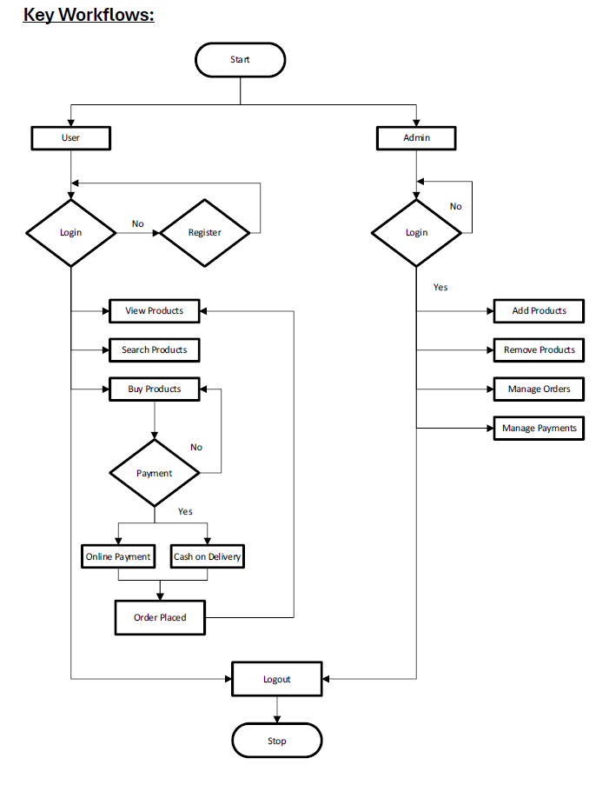

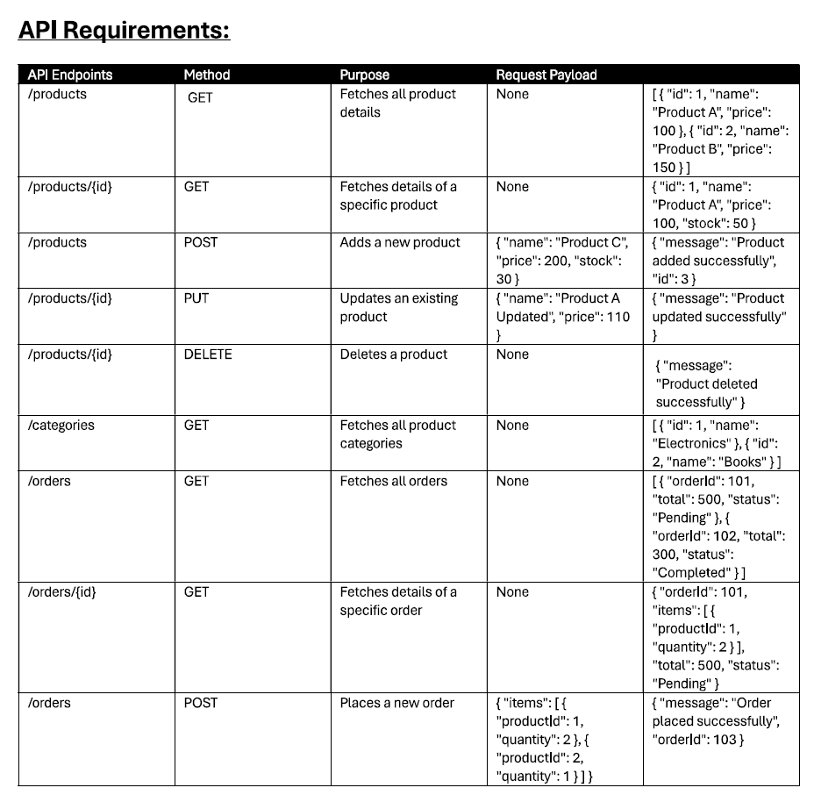

**Product Schema:**

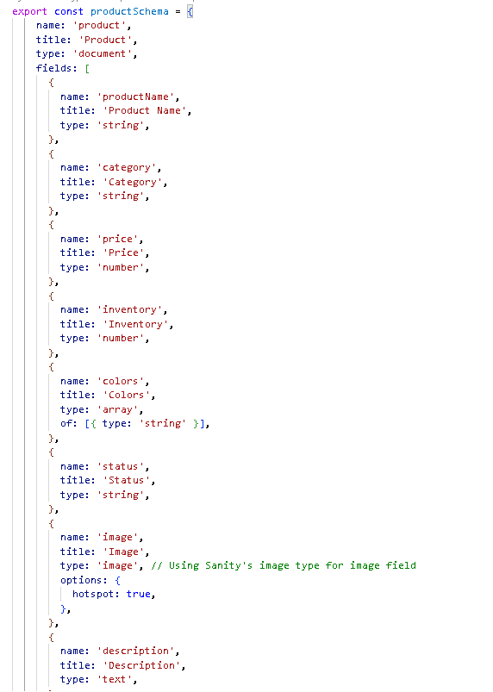

**Quote:**

My experience working this marketplace hackathon is incredible, as it provided me valuable insights into business operations and how business work, enhancing my skills into next level.